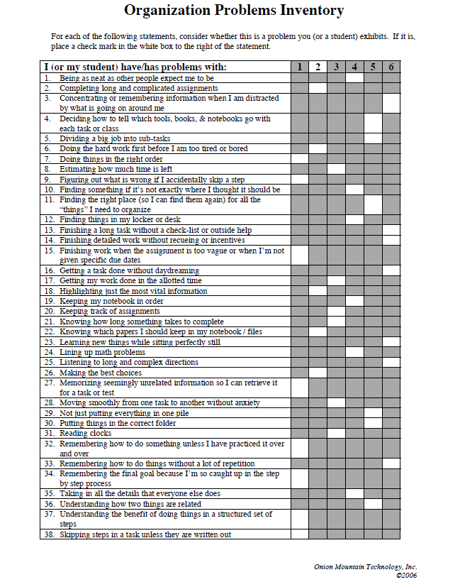

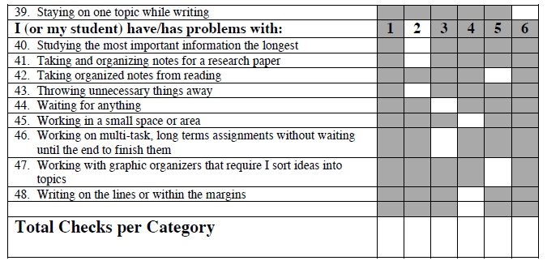
1 = Sequential Organization Problems
2 = Prioritization Organization Problems
3 = Temporal Organization Problems
4 = Spatial Organization Problems
5 = Categorical (Semantic) Organization Problems
6 = Attention Organization Problems

Scoring and Interpretation:
Generally speaking, we have found the following is true of the total checks per category boxes scores:
􀀁 0-3 checks indicate a low to non-existent degree of organization problems in this category.
􀀁 4 checks in a category can be symptomatic of problems for some people but could still be found in a person who is functioning with some degree of organizational success in this category.
􀀁 5-8 checks almost always indicate functional problems in this category of organizational problems.
􀀁 Most people who have organizational problems have one category that is relatively high (7-8) and 2 other areas that are less problematic (4-7). We always suggest trying to deal with the category that has the most problems because “fixing” it can affect other areas.
􀀁 If attention is the major area, regardless of its number score, start trying to deal with it first. It always affects the other categories of organization problems.

Specifically, we also have noted:
􀀁 That sometimes problems are related to learning styles. For example, someone who checked #3 and #26 may have attention problems or they may simply have problems with auditory distracters.
􀀁 Students, parents, and teachers often see problems quite differently. For older students, I try to have all three categories of people fill out the inventory for the student being evaluated. While most everyone recognizes the most problematic categories, what is seen as most problematic by the student is often not the same category reported by parents and teachers. Starting with what the student thinks is most problematic is a good way to start dealing with organization problems because the student is most invested in finding a way to remediate the problem they identify as their worst area of organization.
􀀁 A few people have told us that they need to fill out the inventory for different environments in their lives (home, work, school, etc.). While some problems seem to carry across environments, spatial problems, in particular, reportedly differ according to the environment the person is in and with whom they are living or working.

