Within Microsoft Word and other free tools on the Internet, you can get a Flesch readability score. The program looks at sentence length, and words with multi syllables. It calculates all of your paper together and gives you an Ease of reading score by grade levels. If your paper comes out at a 4.5 that means a 4th grader would easily be able to read your text.

Word
- Click the Microsoft Office Button, and then click Word Options.
- Click Proofing.
- Make sure Check grammar with spelling is selected.
- Under When correcting grammar in Word, select the Show readability statistics check box.

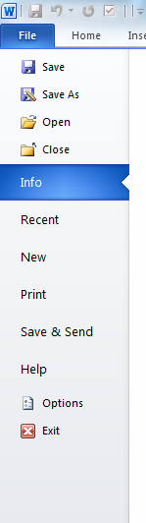1.

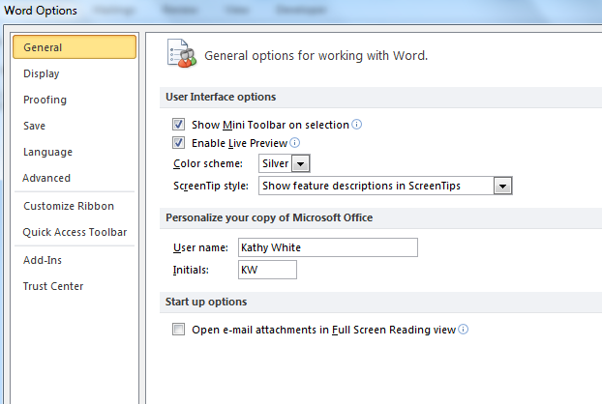2.

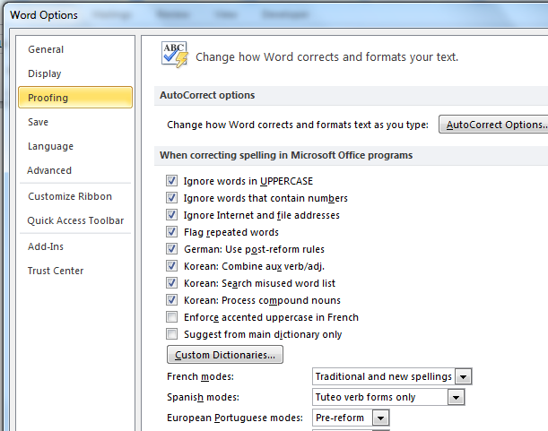3.

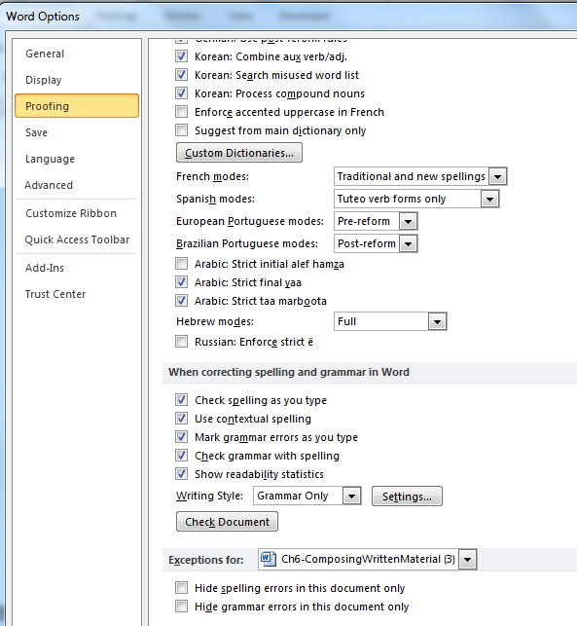4.

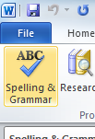5.

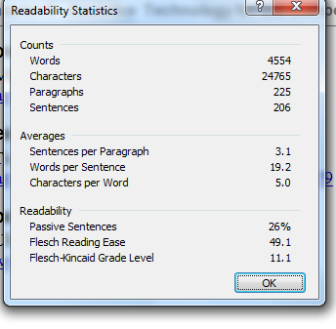6 Once you have run a spell check, this is what you see. This piece is grade 11.1

